-- Patients Table

CREATE TABLE Patients (

patient_id INT PRIMARY KEY,

patient_name VARCHAR(100) NOT NULL,

gender VARCHAR(10),

date_of_birth DATE,

contact_number1 VARCHAR(20),

contact_number2 VARCHAR(20),

address_line1 VARCHAR(255),

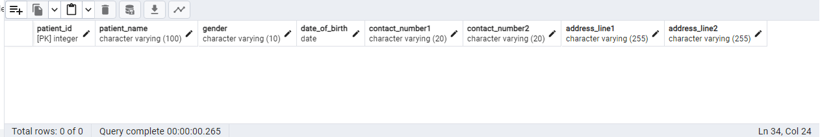 address_line2 VARCHAR(255));

INSERT INTO Patients (patient_id, patient_name, gender, date_of_birth, contact_number1, contact_number2, address_line1, address_line2)

VALUES

(1, 'Amit Patel', 'Male', '1985-03-15', '+91-9876543210', '+91-8765432109', '123, Shyamal Avenue', 'Satellite, Ahmedabad'),

(2, 'Riya Shah', 'Female', '1992-07-21', '+91-7890123456', '+91-8901234567', '456, Mansi Circle', 'Vastrapur, Ahmedabad'),

(3, 'Suresh Desai', 'Male', '1980-05-08', '+91-8765432101', '+91-7654321098', '789, Ashram Road', 'Ellis Bridge, Ahmedabad'),

(4, 'Jaya Patel', 'Female', '1995-11-30', '+91-7654321090', '+91-6543210987', '234, CG Road', 'Navrangpura, Ahmedabad'),

(5, 'Vivek Shah', 'Male', '1988-09-17', '+91-9876543211', '+91-8765432100', '567, Drive-In Road', 'Thaltej, Ahmedabad'),

(6, 'Neha Patel', 'Female', '1987-12-03', '+91-8765432102', '+91-7654321091', '890, Science City Road', 'Sola, Ahmedabad'),

(7, 'Rajesh Mehta', 'Male', '1983-04-28', '+91-9876543212', '+91-8765432103', '111, Riverfront Road', 'Sabarmati, Ahmedabad'),

(8, 'Aishwarya Shah', 'Female', '1990-02-14', '+91-9876543213', '+91-8765432104', '222, Prahlad Nagar', 'Satellite, Ahmedabad'),

(9, 'Dinesh Patel', 'Male', '1979-06-19', '+91-9876543214', '+91-8765432105', '333, Gurukul Road', 'Memnagar, Ahmedabad'),

(10, 'Pooja Shah', 'Female', '1984-10-25', '+91-9876543215', '+91-8765432106', '444, Ambawadi', 'Paldi, Ahmedabad'),

(11, 'Ankit Patel', 'Male', '1982-08-12', '+91-9876543216', '+91-8765432107', '555, Drive-In Road', 'Thaltej, Ahmedabad'),

(12, 'Rashmi Shah', 'Female', '1993-09-08', '+91-9876543217', '+91-8765432108', '666, Science City Road', 'Sola, Ahmedabad'),

(13, 'Kunal Mehta', 'Male', '1981-07-05', '+91-9876543218', '+91-8765432109', '777, CG Road', 'Navrangpura, Ahmedabad'),

(14, 'Smita Patel', 'Female', '1986-06-02', '+91-9876543219', '+91-8765432110', '888, Prahlad Nagar', 'Satellite, Ahmedabad'),

(15, 'Rajat Shah', 'Male', '1989-11-11', '+91-9876543220', '+91-8765432111', '999, Gurukul Road', 'Memnagar, Ahmedabad'),

(16, 'Khushi Shah', 'Female', '1991-12-18', '+91-9876543221', '+91-8765432112', '101, Ambawadi', 'Paldi, Ahmedabad'),

(17, 'Deepak Patel', 'Male', '1987-03-23', '+91-9876543222', '+91-8765432113', '202, Riverfront Road', 'Sabarmati, Ahmedabad'),

(18, 'Ritika Shah', 'Female', '1984-04-19', '+91-9876543223', '+91-8765432114', '303, Mansi Circle', 'Vastrapur, Ahmedabad'),

(19, 'Harish Patel', 'Male', '1980-01-09', '+91-9876543224', '+91-8765432115', '404, Shyamal Avenue', 'Satellite, Ahmedabad'),

(20, 'Mona Shah', 'Female', '1988-02-27', '+91-9876543225', '+91-8765432116', '505, Drive-In Road', 'Thaltej, Ahmedabad');

-- Doctors Table

CREATE TABLE Doctors (

doctor_id INT PRIMARY KEY,

doctor_name VARCHAR(100) NOT NULL,

specialization VARCHAR(100),

contact_number VARCHAR(20),

email VARCHAR(100),

department_id INT,

FOREIGN KEY (department_id) REFERENCES Departments(department_id)

);

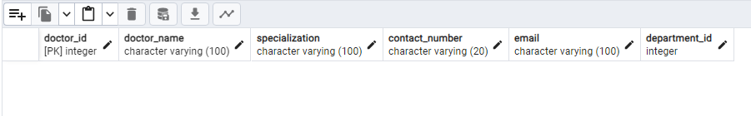

INSERT INTO Doctors (doctor_id, doctor_name, specialization, contact_number, email, department_id)

VALUES

(1, 'Dr. Anil Kumar', 'Cardiologist', '+91-9876543210', 'anil.kumar@example.com', 1),

(2, 'Dr. Neha Sharma', 'Dermatologist', '+91-9876543211', 'neha.sharma@example.com', 2),

(3, 'Dr. Rajesh Singh', 'Orthopedic Surgeon', '+91-9876543212', 'rajesh.singh@example.com', 1),

(4, 'Dr. Pooja Verma', 'Gynecologist', '+91-9876543213', 'pooja.verma@example.com', 3),

(5, 'Dr. Vikram Gupta', 'Neurologist', '+91-9876543214', 'vikram.gupta@example.com', 2),

(6, 'Dr. Smita Patel', 'Oncologist', '+91-9876543215', 'smita.patel@example.com', 3),

(7, 'Dr. Rohit Malhotra', 'Pediatrician', '+91-9876543216', 'rohit.malhotra@example.com', 2),

(8, 'Dr. Nisha Singh', 'Psychiatrist', '+91-9876543217', 'nisha.singh@example.com', 1),

(9, 'Dr. Sunil Kapoor', 'Urologist', '+91-9876543218', 'sunil.kapoor@example.com', 3),

(10, 'Dr. Anjali Sharma', 'Ophthalmologist', '+91-9876543219', 'anjali.sharma@example.com', 1),

(11, 'Dr. Arjun Khanna', 'Dentist', '+91-9876543220', 'arjun.khanna@example.com', 2),

(12, 'Dr. Ritu Gupta', 'ENT Specialist', '+91-9876543221', 'ritu.gupta@example.com', 3),

(13, 'Dr. Manoj Saxena', 'Gastroenterologist', '+91-9876543222', 'manoj.saxena@example.com', 1),

(14, 'Dr. Meera Verma', 'Dietitian', '+91-9876543223', 'meera.verma@example.com', 2),

(15, 'Dr. Sameer Kapoor', 'Dermatologist', '+91-9876543224', 'sameer.kapoor@example.com', 3),

(16, 'Dr. Kavita Sharma', 'Psychologist', '+91-9876543225', 'kavita.sharma@example.com', 1),

(17, 'Dr. Rajat Mehta', 'Cardiologist', '+91-9876543226', 'rajat.mehta@example.com', 2),

(18, 'Dr. Nandini Patel', 'Endocrinologist', '+91-9876543227', 'nandini.patel@example.com', 3),

(19, 'Dr. Siddharth Malhotra', 'Oncologist', '+91-9876543228', 'siddharth.malhotra@example.com', 1),

(20, 'Dr. Alisha Singh', 'Neurologist', '+91-9876543229', 'alisha.singh@example.com', 2);

-- Appointments Table

CREATE TABLE Appointments (

appointment_id SERIAL PRIMARY KEY,

patient_id INT,

doctor_id INT,

appointment_date DATE,

appointment_time TIME,

status VARCHAR(20),

FOREIGN KEY (patient_id) REFERENCES Patients(patient_id),

FOREIGN KEY (doctor_id) REFERENCES Doctors(doctor_id)

);

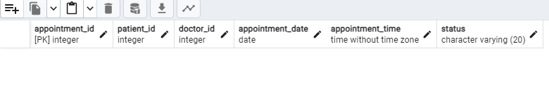

INSERT INTO Appointments (patient_id, doctor_id, appointment_date, appointment_time, status)

VALUES

(1, 1, '2023-10-10', '10:00:00', 'Scheduled'),

(2, 3, '2023-10-11', '14:30:00', 'Scheduled'),

(3, 5, '2023-10-12', '11:15:00', 'Scheduled'),

(4, 2, '2023-10-13', '09:45:00', 'Completed'),

(5, 7, '2023-10-14', '16:20:00', 'Cancelled'),

(6, 4, '2023-10-15', '13:00:00', 'Scheduled'),

(7, 9, '2023-10-16', '10:45:00', 'Scheduled'),

(8, 6, '2023-10-17', '15:30:00', 'Scheduled'),

(9, 8, '2023-10-18', '14:00:00', 'Completed'),

(10, 10, '2023-10-19', '12:30:00', 'Cancelled'),

(11, 12, '2023-10-20', '17:15:00', 'Scheduled'),

(12, 14, '2023-10-21', '11:45:00', 'Scheduled'),

(13, 11, '2023-10-22', '14:10:00', 'Scheduled'),

(14, 13, '2023-10-23', '10:25:00', 'Completed'),

(15, 15, '2023-10-24', '16:40:00', 'Cancelled'),

(16, 17, '2023-10-25', '13:55:00', 'Scheduled'),

(17, 16, '2023-10-26', '15:20:00', 'Scheduled'),

(18, 18, '2023-10-27', '09:30:00', 'Completed'),

(19, 20, '2023-10-28', '18:05:00', 'Scheduled'),

(20, 19, '2023-10-29', '12:15:00', 'Scheduled');

-- Departments Table

CREATE TABLE Departments (

department_id INT PRIMARY KEY,

department_name VARCHAR(100) NOT NULL

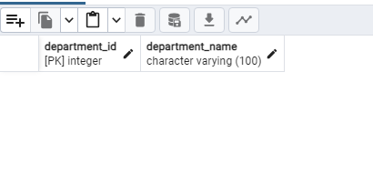);

INSERT INTO Departments (department_id, department_name) VALUES

(1, 'Cardiology'),

(2, 'Orthopedics'),

(3, 'Neurology'),

(4, 'Oncology'),

(5, 'Pediatrics'),

(6, 'Gynecology'),

(7, 'Dermatology'),

(8, 'Ophthalmology'),

(9, 'ENT'),

(10, 'Urology'),

(11, 'Psychiatry'),

(12, 'Radiology'),

(13, 'Internal Medicine'),

(14, 'Emergency Medicine'),

(15, 'Anesthesiology'),

(16, 'Pathology'),

(17, 'Physical Therapy'),

(18, 'Occupational Therapy'),

(19, 'Nephrology'),

(20, 'Endocrinology');

-- Medical Records Table

CREATE TABLE MedicalRecords (

record_id INT PRIMARY KEY,

patient_id INT,

doctor_id INT,

admission_date DATE,

discharge_date DATE,

diagnosis VARCHAR(255),

prescription TEXT,

FOREIGN KEY (patient_id) REFERENCES Patients(patient_id),

FOREIGN KEY (doctor_id) REFERENCES Doctors(doctor_id)

);

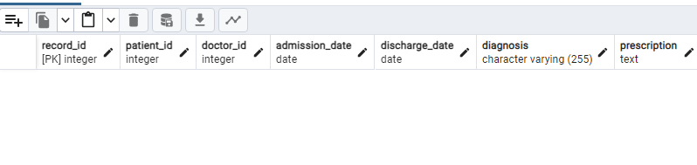

INSERT INTO MedicalRecords (record_id, patient_id, doctor_id, admission_date, discharge_date, diagnosis, prescription)

VALUES

(1, 1, 1, '2023-01-05', '2023-01-10', 'Common Cold', 'Rest and fluids.'),

(2, 2, 3, '2023-02-12', '2023-02-20', 'Influenza', 'Prescribed antiviral medication.'),

(3, 4, 2, '2023-03-18', '2023-03-25', 'Allergic Reaction', 'Avoid allergen. Prescribed allergy medication.'),

(4, 5, 5, '2023-04-02', '2023-04-09', 'Sprained Ankle', 'Rest, ice, compression, elevation (RICE).'),

(5, 3, 4, '2023-05-15', '2023-05-22', 'Gastric Problems', 'Dietary changes and antacids.'),

(6, 6, 6, '2023-06-08', '2023-06-15', 'Migraine', 'Prescribed pain relievers. Avoid triggers.'),

(7, 7, 7, '2023-07-03', '2023-07-10', 'Hypertension', 'Prescribed blood pressure medication. Dietary changes.'),

(8, 8, 8, '2023-08-20', '2023-08-28', 'Diabetes Management', 'Insulin therapy and dietary control.'),

(9, 9, 9, '2023-09-12', '2023-09-20', 'Chronic Back Pain', 'Physical therapy and pain relievers.'),

(10, 10, 10, '2023-10-01', '2023-10-07', 'Sinusitis', 'Nasal irrigation and prescribed antibiotics.'),

(11, 11, 11, '2023-11-18', '2023-11-25', 'Urinary Tract Infection', 'Prescribed antibiotics and increased fluid intake.'),

(12, 12, 12, '2023-12-05', '2023-12-12', 'Anxiety Disorder', 'Therapy sessions and prescribed anti-anxiety medication.'),

(13, 13, 13, '2024-01-08', '2024-01-15', 'Dermatitis', 'Topical creams and avoiding irritants.'),

(14, 14, 14, '2024-02-22', '2024-03-01', 'Acute Bronchitis', 'Rest, fluids, and prescribed cough syrup.'),

(15, 15, 15, '2024-03-15', '2024-03-22', 'Gastroenteritis', 'Oral rehydration therapy and bland diet.'),

(16, 16, 16, '2024-04-02', '2024-04-09', 'Seasonal Allergies', 'Antihistamines and avoiding allergens.'),

(17, 17, 17, '2024-05-18', '2024-05-25', 'Conjunctivitis', 'Prescribed eye drops and keeping eyes clean.'),

(18, 18, 18, '2024-06-08', '2024-06-15', 'Tennis Elbow', 'Rest, physical therapy, and pain relievers.'),

(19, 19, 19, '2024-07-03', '2024-07-10', 'Stress-Related Headache', 'Relaxation techniques and pain relievers.'),

(20, 20, 20, '2024-08-20', '2024-08-28', 'Insomnia', 'Sleep hygiene practices and relaxation exercises.');

-- Nurses Table

CREATE TABLE Nurses (

nurse_id INT PRIMARY KEY,

nurse_name VARCHAR(100) NOT NULL,

contact_number VARCHAR(20),

department_id INT,

FOREIGN KEY (department_id) REFERENCES Departments(department_id)

);

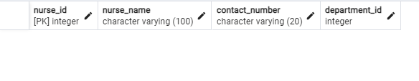

INSERT INTO Nurses (nurse_id, nurse_name, contact_number, department_id)

VALUES

(1, 'Nurse 1', '+91-9876543210', 1),

(2, 'Nurse 2', '+91-9876543211', 2),

(3, 'Nurse 3', '+91-9876543212', 3),

(4, 'Nurse 4', '+91-9876543213', 4),

(5, 'Nurse 5', '+91-9876543214', 5),

(6, 'Nurse 6', '+91-9876543215', 6),

(7, 'Nurse 7', '+91-9876543216', 7),

(8, 'Nurse 8', '+91-9876543217', 8),

(9, 'Nurse 9', '+91-9876543218', 9),

(10, 'Nurse 10', '+91-9876543219', 10),

(11, 'Nurse 11', '+91-9876543220', 1),

(12, 'Nurse 12', '+91-9876543221', 2),

(13, 'Nurse 13', '+91-9876543222', 3),

(14, 'Nurse 14', '+91-9876543223', 4),

(15, 'Nurse 15', '+91-9876543224', 5),

(16, 'Nurse 16', '+91-9876543225', 6),

(17, 'Nurse 17', '+91-9876543226', 7),

(18, 'Nurse 18', '+91-9876543227', 8),

(19, 'Nurse 19', '+91-9876543228', 9),

(20, 'Nurse 20', '+91-9876543229', 10);

-- Beds Table

CREATE TABLE Beds (

bed_number INT PRIMARY KEY,

department_id INT,

status VARCHAR(20),

FOREIGN KEY (department_id) REFERENCES Departments(department_id)

);

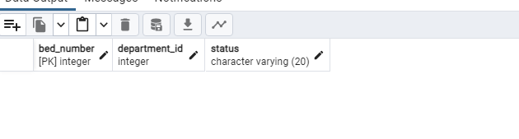

INSERT INTO Beds (bed_number, department_id, status)

VALUES

(1, 1, 'Occupied'),

(2, 1, 'Available'),

(3, 2, 'Occupied'),

(4, 2, 'Available'),

(5, 3, 'Occupied'),

(6, 3, 'Available'),

(7, 4, 'Occupied'),

(8, 4, 'Available'),

(9, 5, 'Occupied'),

(10, 5, 'Available'),

(11, 6, 'Occupied'),

(12, 6, 'Available'),

(13, 7, 'Occupied'),

(14, 7, 'Available'),

(15, 8, 'Occupied'),

(16, 8, 'Available'),

(17, 9, 'Occupied'),

(18, 9, 'Available'),

(19, 10, 'Occupied'),

(20, 10, 'Available');

------------------------Query------------------------

--1. Find patients who have had multiple appointments in the same day

SELECT p.patient_name, a.appointment_date, COUNT(a.appointment_id) AS num_appointments

FROM Patients p

INNER JOIN Appointments a ON p.patient_id = a.patient_id

GROUP BY p.patient_name, a.appointment_date

HAVING COUNT(a.appointment_id) > 1;

--2. List doctors and their number of appointments, ordered by the number of appointments

SELECT d.doctor_name, COUNT(a.appointment_id) AS num_appointments

FROM Doctors d

LEFT JOIN Appointments a ON d.doctor_id = a.doctor_id

GROUP BY d.doctor_name

ORDER BY num_appointments DESC;

--3. Retrieve all departments along with the number of doctors in each department

SELECT d.department_name, COUNT(doc.doctor_id) AS num_doctors

FROM Departments d

LEFT JOIN Doctors doc ON d.department_id = doc.department_id

GROUP BY d.department_name;

--4. List patients with medical records diagnosed with 'Fever'

SELECT p.patient_name, m.diagnosis

FROM Patients p

INNER JOIN MedicalRecords m ON p.patient_id = m.patient_id

WHERE m.diagnosis = 'Fever';

--5. retrieves all appointments for a specific patient ID

CREATE OR REPLACE FUNCTION GetPatientAppointments(patientId INT) RETURNS TABLE (

appointment_id INT,

appointment_date DATE,

appointment_time TIME,

doctor_name VARCHAR(100),

status VARCHAR(20)

) AS $$

BEGIN

RETURN QUERY

SELECT a.appointment_id, a.appointment_date, a.appointment_time, d.doctor_name, a.status

FROM Appointments a

INNER JOIN Doctors d ON a.doctor_id = d.doctor_id

WHERE a.patient_id = patientId;

END;

$$ LANGUAGE plpgsql;

-- Call the stored procedure for patient with ID 1

SELECT * FROM GetPatientAppointments(1);

--6. Crate a function that retrieves the age of the pateint by the given date of birth

CREATE OR REPLACE FUNCTION CalculatePatientAge() RETURNS TABLE (

patient_id INT,

patient_name VARCHAR(100),

age INT

) AS $$

DECLARE

patient_record Patients%ROWTYPE;

BEGIN

-- Cursor to fetch patient records

FOR patient_record IN (SELECT * FROM Patients)

LOOP

-- Calculate age using date_of_birth and current date

age := EXTRACT(YEAR FROM age(current_date, patient_record.date_of_birth));

-- Return patient_id, patient_name, and age

RETURN QUERY SELECT patient_record.patient_id, patient_record.patient_name, age;

END LOOP;

END;

$$ LANGUAGE plpgsql;

SELECT * FROM CalculatePatientAge();

--7. Write a PL/pgSQL function named CalculateAveragePatientAge that calculates the

--average age of patients based on their date_of_birth in the Patients table.

CREATE OR REPLACE FUNCTION CalculateAveragePatientAge() RETURNS NUMERIC AS $$

DECLARE

total_age NUMERIC := 0;

total_patients INT := 0;

average_age NUMERIC;

patient_dob DATE;

BEGIN

-- Cursor to fetch date_of_birth values

FOR patient_dob IN (SELECT date_of_birth FROM Patients)

LOOP

total_age := total_age + EXTRACT(YEAR FROM age(current_date, patient_dob));

total_patients := total_patients + 1;

END LOOP;

-- Calculate average age

IF total_patients > 0 THEN

average_age := total_age / total_patients;

ELSE

average_age := 0;

END IF;

RETURN average_age;

END;

$$ LANGUAGE plpgsql;

SELECT * FROM CalculateAveragePatientAge();

--8. Create a cursor to fetch patient information for specific doctors' appointments

DO $$

DECLARE

doctor_id_to_query INT := 1; -- Specify the doctor's ID for whom you want to fetch patients' information

patient_record Patients%ROWTYPE;

appointment_record Appointments%ROWTYPE;

-- Declare a cursor to fetch patients based on doctor_id

patient_cursor cursor for

SELECT * FROM Patients WHERE patient_id IN (SELECT patient_id FROM Appointments WHERE doctor_id = doctor_id_to_query);

BEGIN

-- Open and fetch data from the patient_cursor

OPEN patient_cursor;

-- Loop through the cursor and fetch patient details

LOOP

FETCH patient_cursor INTO patient_record;

EXIT WHEN NOT FOUND;

-- Fetch appointment details for the patient

SELECT * INTO appointment_record FROM Appointments WHERE patient_id = patient_record.patient_id AND doctor_id = doctor_id_to_query;

-- Display patient and appointment information

RAISE NOTICE 'Patient ID: %, Patient Name: %, Appointment ID: %, Appointment Date: %',

patient_record.patient_id, patient_record.patient_name,

appointment_record.appointment_id, appointment_record.appointment_date;

END LOOP;

-- Close the cursor

CLOSE patient_cursor;

END $$;

--9. to create a cursor query that fetches the patient name,

--doctor name, and appointment date for each medical record

DO $$

DECLARE

patient_name VARCHAR(100);

doctor_name VARCHAR(100);

appointment_date DATE;

medical_record_cursor CURSOR FOR

SELECT p.patient_name, d.doctor_name, a.appointment_date

FROM Appointments a

JOIN Patients p ON a.patient_id = p.patient_id

JOIN Doctors d ON a.doctor_id = d.doctor_id;

BEGIN

-- Open the medical_record_cursor

OPEN medical_record_cursor;

-- Loop through the cursor and fetch data for each medical record

LOOP

-- Fetch data from the cursor

FETCH medical_record_cursor INTO patient_name, doctor_name, appointment_date;

EXIT WHEN NOT FOUND;

-- Display patient name, doctor name, and appointment date

RAISE NOTICE 'Patient Name: %, Doctor Name: %, Appointment Date: %', patient_name, doctor_name, appointment_date;

END LOOP;

-- Close the cursor

CLOSE medical_record_cursor;

END $$;

--10. retrieves the number of appointments made by each patient.

CREATE OR REPLACE PROCEDURE GetAppointmentCounts()

LANGUAGE plpgsql

AS $$

DECLARE

patient_record RECORD;

patient_id INT;

patient_name VARCHAR(100);

appointment_count INT;

BEGIN

-- Fetch patient IDs and their corresponding appointment counts

FOR patient_record IN (SELECT p.patient_id, p.patient_name, COUNT(a.appointment_id) AS num_appointments

FROM Patients p

LEFT JOIN Appointments a ON p.patient_id = a.patient_id

GROUP BY p.patient_id, p.patient_name)

LOOP

-- Assign values to variables

patient_id := patient_record.patient_id;

patient_name := patient_record.patient_name;

appointment_count := patient_record.num_appointments;

-- Display patient name and appointment count

RAISE NOTICE 'Patient ID: %, Patient Name: %, Number of Appointments: %', patient_id, patient_name, appointment_count;

END LOOP;

END;

$$;

CALL GetAppointmentCounts();

--11. Retrive the total medical cost for the given patient id

CREATE OR REPLACE PROCEDURE CalculateTotalMedicalCost(patient_id_input INT)

LANGUAGE plpgsql

AS $$

DECLARE

total_cost NUMERIC := 0;

BEGIN

-- Calculate total medical cost for the given patient

SELECT SUM(total_cost) INTO total_cost

FROM MedicalRecords

WHERE patient_id = patient_id_input;

-- Display total medical cost

RAISE NOTICE 'Total Medical Cost for Patient %: %', patient_id_input, total_cost;

END;

$$;

-- Example usage: Call the procedure with a specific patient ID

CALL CalculateTotalMedicalCost(1); -- Replace '1' with the desired patient ID

--12. Retrieve the total number of occupied beds in each department

SELECT d.department_name, COUNT(b.bed_number) AS occupied_beds

FROM Departments d

LEFT JOIN Beds b ON d.department_id = b.department_id AND b.status = 'Occupied'

GROUP BY d.department_name;

--13. Retrieve nurses along with their assigned departments

SELECT n.nurse_name, d.department_name

FROM Nurses n

JOIN Departments d ON n.department_id = d.department_id;

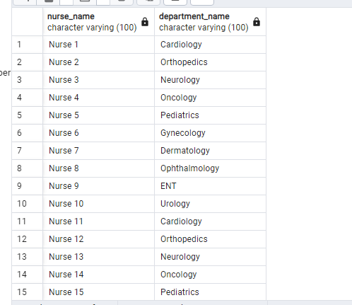

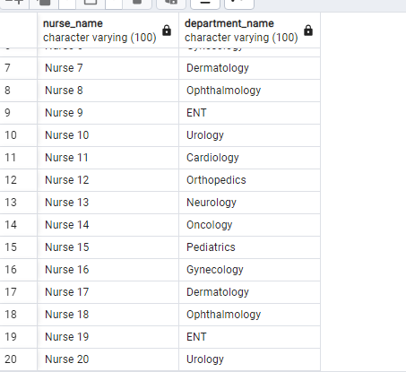

--14. Retrieve the department with the highest number of occupied beds

SELECT d.department_name, COUNT(b.bed_number) AS occupied_beds

FROM Departments d

LEFT JOIN Beds b ON d.department_id = b.department_id AND b.status = 'Occupied'

GROUP BY d.department_name

ORDER BY COUNT(b.bed_number) DESC

LIMIT 1;

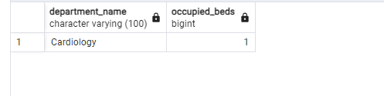

--15. Retrieve patients who have had more than one appointment with the same doctor.

SELECT p.patient_name, d.doctor_name, COUNT(a.appointment_id) AS num_appointments

FROM Patients p

JOIN Appointments a ON p.patient_id = a.patient_id

JOIN Doctors d ON a.doctor_id = d.doctor_id

GROUP BY p.patient_name, d.doctor_name

HAVING COUNT(a.appointment_id) > 1;

--16. Retrieve doctors and the number of different patients they have treated

SELECT d.doctor_name, COUNT(DISTINCT a.patient_id) AS num_patients

FROM Doctors d

JOIN Appointments a ON d.doctor_id = a.doctor_id

GROUP BY d.doctor_name;